Study Material
<Program Code: CO/CM/CW/DE/EJ/ET/EN/EX/EQ/IE/IS/IC/MU>: <Course Code:22320><Course Name: Digital Techniques><Topic Name: Number Systems and code>
<UO1a.2.><study Material>

Course Expert: Mrs. Rita Vora | Date:07/07/2020 | Mentor: Mr. K. P. Akole  Co-ordinator: Mrs Nirmala Kamble
Key words  Number System , Radix , Decimal , Binary , Hexadecimal, Octal | Learning Objective: To convert the given number from one number system to another such as Binary, Decimal, octal, Hexadecimal. | Numbers have positional importance  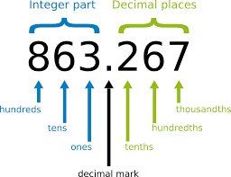
Key Questions  Do You know the importance of Number System?  Name the number system used in Computers. | Concept Map  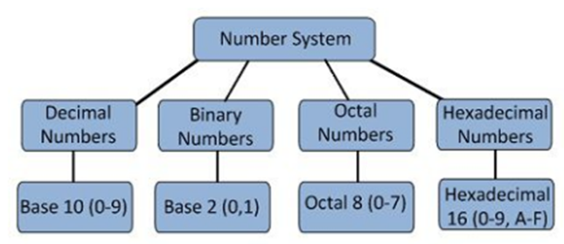
 | Number Systems:  The number system is a way to represent or express numbers. It is the mathematical notation for representing numbers of a given set by using digits or other symbols in a consistent manner. A digital system can understand positional number system only when there are few digits and symbols that represents different values depending on the position they occupy in the number. Hence Number system provides a unique representation of every number and represents the arithmetic and algebraic structure of the figures.  (Cont. on next page) | Key Definitions  Number Systems:  The number system is a way to represent or express numbers  Radix: The number of values that a digit can have is equal to the base or Radix of the system
Solved word Problem

Give the radix of the four number systems

The radix for Decimal number system is 10, for Binary number system is 2, for Hexadecimal number system is 16 and Octal number system is 8.

 | Application of Number Systems  - Computers  - Mathematical algorithm and calculations  - Digital Systems  - Microprocessors | Link to YouTube/ OER/ video  https://www.mathsisfun.com/binary-number-system.html

The value of any digit in a number can be determined by:
• The digit
• Position of digit in the number before and after decimal point
• The base of the number system

RADIX or BASE:
In a positional numeral system, the radix or base is the number of unique digits, including the digit zero, used to represent numbers. For example, for decimal system (the most common system in use today) the radix (base number) is 10, because it uses ten digits i.e. from 0 to 9 in which every digit can have 10 distinct values (0, 1, 2…….9).
The largest value of a digit is always one less than the base: For example, the largest digit in a decimal system is 9 (one less than the base 10).
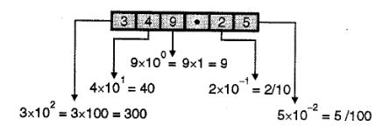
The position (place) of every digit represents a different multiple of base i.e. the number have positional importance: For example, consider the decimal number (349.25)₁₀ shown in Figure below:

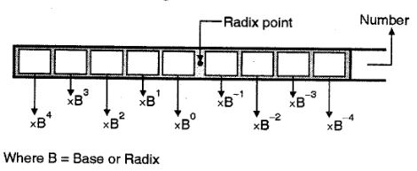
Hence, we can implement a common rule for all the numbering systems, for a general number we have to multiply each of digit by some power of base or radix as show in figure :

.TYPES OF NUMBER SYSTEM
There are various types of the number system, the four most common number system types are:
1. Decimal number system (Base-10)
2. Binary number system (Base-2)
3. Octal number system (Base-8)
4. Hexadecimal number system (Base-16)

These number systems are explained below in detail.
Decimal Number System
The number system having digit from 0, 1, 2……9 is known as a decimal number system because total ten digits are involved. The base of the decimal number system is 10.
Characteristics of a Decimal Number System
- The base or radix of Decimal number system is 10.
- The part of the number that lies to the left of the decimal point is known as integer part. Similarly, the part of the number that lies to the right of the decimal point is known as fractional part.
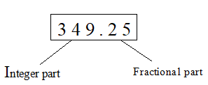
- In this number system each place of a digit represents a different multiple of 10. These multiples are called as weighted values.
- The digits having successive position to the left side of the decimal point have weights of 10⁰, 10¹, 10², 10³ and so on. Similarly, the digits having successive position to the right side of the decimal point have weights of 10⁻¹, 10⁻², 10⁻³ and so on. That means, each position has specific weight, which is power of base 10.
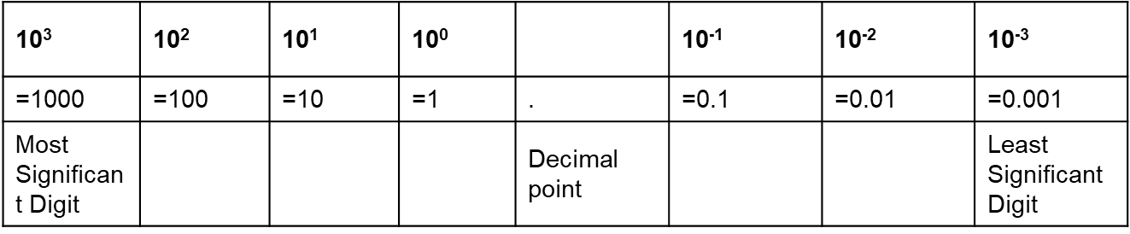
- The weighted values for different positions of a digit in decimal number system is shown in figure:

Most Significant Digit (MSD): The leftmost digit having the highest weight is called as the most significant digit of a number.
Least Significant Digit (LSD): The rightmost digit having the lowest weight is called as the least significant digit of a number.
Example
1) Represent the decimal number 1358.246 in terms of power of 10.
Solution: Integer part of this number is 1358 and fractional part of this number is 0.246. The digits 8, 5, 3 and 1 have weights of 10⁰, 10¹, 10² and 10³ respectively. Similarly, the digits 2, 4 and 6 have weights of 10⁻¹, 10⁻² and 10⁻³ respectively.
Hence, we write it as
1358.246 = (1 × 10³) + (3 × 10²) + (5 × 10¹) + (8 × 10⁰) + (2 × 10⁻¹) +(4 × 10⁻²) + (6 × 10⁻³).

Binary Number System
The modern digital systems do not process decimal number rather they work with another number system known as a binary number system whose radix or base is 2 and its elements or digits will be 0 & 1 only. This system is known as binary number system as its radix is 2. The digits 0 & 1 of this system are known as bits. This number system finds extensive use in digital electronics.
Characteristics of Binary Numbers System
- The base or radix of this number system is 2.
- The part of the number, which lies to the left of the binary point is known as integer part. Similarly, the part of the number, which lies to the right of the binary point is known as fractional part.
- In this number system, the digits having successive position to the left side of the binary point have weights of 2⁰, 2¹, 2², 2³ and so on. Similarly, the digit having successive positions to the right of the binary point have weights of 2⁻¹, 2⁻², 2⁻³ and so on, means each position has specific weight, which is power of base 2.
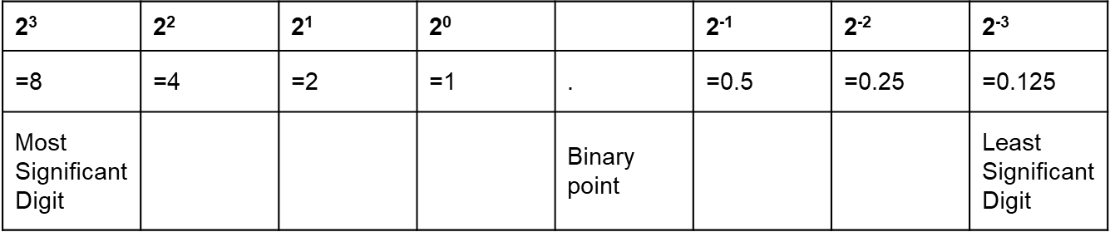
- The weighted values for different positions of a digit in binary number system is shown in figure:

- The left most bit in a given binary number with the highest weight is called as Most significant bit (MSB) whereas the right most bit in a given binary number with lowest weight is called as least significant bit (LSB).
- The binary number system requires a very long string of 1’s and 0’s to represent a decimal number hence it is a drawback of binary number system.
The table below illustrates the counting from 0 to 15 in binary system with their decimal equivalents
Binary number | Decimal equivalent
0 0 0 0 | 0
0 0 0 1 | 1
0 0 1 0 | 2
0 0 1 1 | 3
0 1 0 0 | 4
0 1 0 1 | 5
0 1 1 0 | 6
0 1 1 1 | 7
1 0 0 0 | 8
1 0 0 1 | 9
1 0 1 0 | 10
1 0 1 1 | 11
1 1 0 0 | 12
1 1 0 1 | 13
1 1 1 0 | 14
1 1 1 1 | 15
Example
- Represent the binary number1101.011 in terms of power of 2.
Solution: Integer part of this number is 1101 and fractional part of this number is 0.011. The digits 1, 0, 1 and 1 of integer part have weights of 2⁰, 2¹, 2², 2³ respectively. Similarly, the digits 0, 1 and 1 of fractional part have weights of 2⁻¹, 2⁻², 2⁻³ respectively.
Hence, we write it as
1101.011 = (1 × 2³) + (1 × 2²) + (0 × 2¹) + (1 × 2⁰) + (0 × 2⁻¹) +
(1 × 2⁻²) + (1 × 2⁻³)
Octal Number System
In the octal number system, the base is 8 and it uses digits from 0 to 7 to represent numbers. Octal number systems are used to reduce the size of large binary numbers and are commonly used in computer applications. It is important to note that, digital circuits and computers internally work strictly with the binary structure, and not with octal structure. The octal structure is used only as the convenience of the user.
Characteristics of Octal Number System
- The base or radix of this number system is 8.
- The largest value of a digit in octal system is 7.
- The part of the number, which lies to the left of the octal point is known as integer part. Similarly, the part of the number, which lies to the right of the binary point is known as fractional part.
- In this number system, the digits having successive position to the left side of the octal point have weights of 8⁰, 8¹, 8², 8³ and so on. Similarly, the digit having successive positions to the right of the octal point have weights of 8⁻¹, 8⁻², 8⁻³ and so on, means each position has specific weight, which is power of base 8.
- The weighted values for different positions of a digit in octal number system is shown in figure:
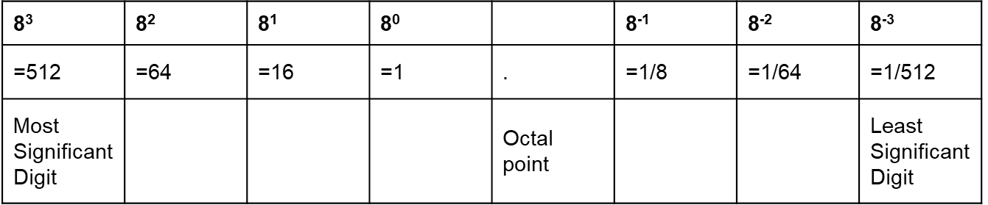
Example
3) Represent the octal number 1457.236 in terms of power of 8.
Solution: Integer part of this number is 1457 and fractional part of this number is 0.236. The digits 7, 5, 4 and 1 have weights of 8⁰, 8¹, 8² and 8³ respectively. Similarly, the digits 2, 3 and 6 have weights of 8⁻¹, 8⁻², 8⁻³ respectively.
Hence, we write it as
1457.236 = (1 × 8³) + (4 × 8²) + (5 × 8¹) + (7 × 80) + (2 × 8-¹) +(3 × 8⁻²) + (6 × 8⁻³)
Hexadecimal Number System
In the hexadecimal system, numbers are written or represented with base 16. In the hex system, the numbers are first represented just like in decimal system i.e. from 0 to 9. Then, the numbers are represented using the alphabets from A to F. The size of the hexadecimal number is much shorter than the binary number which makes them easy to write and remember. These numbers are used extensively in microprocessor/micro-controller work.
The below-given table shows the representation of numbers in the hexadecimal number system.
Hexadecimal
1 2 3 4 5 6 7 8 9 A B C D E F
Decimal
1 2 3 4 5 6 7 8 9 10 11 12 13 14 15
Characteristics of Hexadecimal Number System
The base or radix of this number system is 16.
The largest value of a digit in hexadecimal system is 15 and it is represented by F.
The part of the number, which lies to the left of the hexadecimal point is known as integer part. Similarly, the part of the number, which lies to the right of the binary point is known as fractional part.
In this number system, the digits having successive position to the left side of the hexadecimal point have weights of 16⁰, 16¹, 16², 16³ and so on. Similarly, the digit having successive positions to the right of the hexadecimal point have weights of 16⁻¹, 16⁻², 16⁻³ and so on, means each position has specific weight, which is power of base 16.
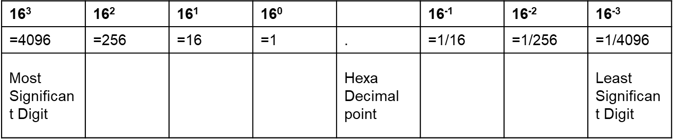
The weighted values for different positions of a digit in hexadecimal number system is shown in figure:

Example
4) Represent the Hexadecimal number 6DE in terms of power of 16.
Solution: Integer part of this number is 6DE and there is no fractional part. Therefore digits E, D and 6 have weights of 16⁰, 16¹, and 16² respectively.
Hence, we write it as
6DE = (6 × 16²) + (13 × 16¹) + (14 × 16⁰)
RELATION BETWEEN BINARY, DECIMAL, OCTAL AND HEXADECIMAL
Decimal  (base 10) | Binary  (base 2) | Hexadecimal  (base 16) | Octal  (base 8)
0 | 0 0 0 0 | 0 | 0
1 | 0 0 0 1 | 1 | 1
2 | 0 0 1 0 | 2 | 2
3 | 0 0 1 1 | 3 | 3
4 | 0 1 0 0 | 4 | 4
5 | 0 1 0 1 | 5 | 5
6 | 0 1 1 0 | 6 | 6
7 | 0 1 1 1 | 7 | 7
8 | 1 0 0 0 | 8 | 10
9 | 1 0 0 1 | 9 | 11
10 | 1 0 1 0 | A | 12
11 | 1 0 1 1 | B | 13
12 | 1 1 0 0 | C | 14
13 | 1 1 0 1 | D | 15
14 | 1 1 1 0 | E | 16
15 | 1 1 1 1 | F | 17
The table below shows relationship between decimal, binary, octal, and hexadecimal numbers from 0 to 15.

CONVERSION OF NUMBER SYSTEMS
The conversion of a number from one number system to another is achieved by expanding the given number to its power series and adding all the terms.
If the given number includes the radix point, then it is necessary to separate the number into an integer part and a fraction part and then each part should be converted separately.
Conversion from Radix “r” to Decimal System
The general procedure for conversion of a number system to decimal system is given below:
Steps to Follow:
1. Note down the given Number.
2. Write down the weights corresponding to different positions.
3. Multiply each digit in the given number with the corresponding weight to obtain product numbers.
4. Add all the product numbers to get the decimal equivalent.
The following examples demonstrate the conversion of binary, octal and hexadecimal number system to its decimal equivalent:
Ex 1: Convert the binary number 1011.01 to its decimal equivalent.
Solution: 1011.01
= (1 x 2³) + (0 x 2²) + (1 x 2¹) + (1 x 2⁰) + (0 x 2⁻¹) + (1 x 2⁻²)
= 8 + 0 + 2 + 1 + 0 + 1/4
Ans: = (11.25)₁₀
Ex 2: Convert the octal number (314)₈ to its decimal equivalent.
Solution: 314
= (3 x 8²) + (1 x 8¹) + (4 x 8⁰)
= 192 + 8 + 4
Ans: = (204)₁₀
Conversion from Decimal to Other Number System (Binary, octal and Hexadecimal

The general procedure for conversion of a decimal number system to any other system is given below:
Steps to Follow:

1. Note down the given Number. Divide the number by the base ‘r’ until there is nothing left, noting the remainder from each step. List the remainder values in reverse order from bottom to top to find the equivalent.
2. If the given decimal number consists a decimal point, then we have to first separate out the integer and fractional part. Then convert them separately to the desired radix and combine the converted parts to obtain the complete converted number.

3. For Integer part:
Divide integer part of the decimal number by base ‘r’ and note down the remainder, continue to divide the quotient until there is nothing left, noting the remainder from each step. List the remainder values in reverse order from bottom to top to find the equivalent.

4. For Fractional part:
- Multiply the fractional part of decimal number by the base ‘r’. Note down the carry generated in the multiplication as MSD.
- Now multiply only the fractional number of the product from previous step by the base ‘r’ and note down the carry as the next bit to MSD.
- Repeat above steps upto the end, the last carry represents LSD now list the values from top to bottom to get converted number.

The following examples demonstrate the conversion of decimal number system to other system

Ex 1Convert (35)₁₀ to binary

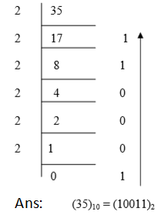

Ex 2 Convert (965.125)10 to Octal

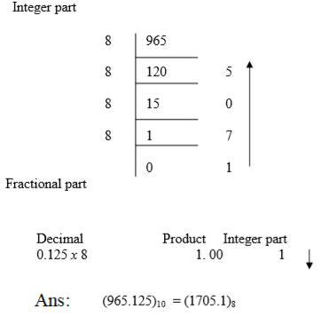

Key Take away from this UO:

Types of Number System :Decimal, Binary, Hexadecimal and Octal
Conversion of one number system to the other.

